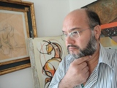 SANTO CARDAMONE (1965)
Pittore - Scultore

PROFESSIONAL EXPERIENCE

- 1973 -1975 Maestro Giuseppe Lauria Falerna (CZ)
Docenza scolastica e scuola di pittura
- 1978 -1983 Vittori Arcese (artista) Roma
Pittura e Scultura.
- 1984- 1986 Michele Cascella (artista) Colle Val D’elsa (Siena) – Milano
Bottega- Studio delle prospettive e del colore.
- 1986 – 1988 Sergio Manzi (artista) San Gimignano (Siena)
Bottega – Disegno figurativo ed anatomia.
- 1986 Istituto Poligrafico e Zecca dello Stato Roma
Official list of the drafters of Stamps.
Realization bozzetti stamps ordinary series “ La salvaguardia della natura”.
- 1986 – 1988 Ministero per i Beni Culturali e Ambientali Roma
Divisione VI° - Riconosciuto come valido Pittore
- 1989– 1990 Grolier International Inc. Research Danbury-U.S.A.
Consultant of Artistic Artifacts.
- 1990 – 1998 Studio Art and artifacts Artistic Siena - I
Active in Italy and abroad, recognized by the European Community.
This guides the Government's French and English.
- 1997-2004 Ministry of Cultural Heritage and Archaeological Cipro
Consultant and expert on Artistic Artifacts and wood.
- 1997 Ass. Nazionale periti D’Arte e Antiquariato Roma
- Writing as an expert in no. 143 sectors Art and Antiquities.
- 1998 University Of Kent – School of Art Canterbury (UK)
Art consultant and teacher.
- 1998-1999 Progetto “Now Penelope” Comunità Europea – Italia -Francia – Inghilterra.
- Designer and director in "Manufacture of wood and Artistic courses".
- 1999 Percorso “I.F.T.S.” Regione Calabria Calabria
- Member of the Technical Committee-scientific section Art Restoration.
- 2000 Unione Europea Periti ed Esperti d’Arte Roma
Writing as an expert recognized on the whole European territory.
- 2000- 2005 IRIDE HOLDINGS Ltd - General Manager Cyprus
Consultant Technical and Diagnostic Center of Art
( Oman – Emirates – Cyprus – Libano – Russia – ecc..)

EXHIBITIONS ART (Personal and Collective)
- 1982 Istituto Perri Lamezia Terme (CZ)
- 1983 Istituto ISART Milano
- 1984 Pittori contemporanei Roma
- 1984 Galleria Umberto I Napoli
- 1984 Palazzo Bagotti Milano
- 1985 Comune di Colle Val d’Elsa Siena
- 1986 Castello La Rocca San Gimignano (Siena)
- 1987 Palazzo Comunale Gambassi Terme
- 1987 Palazzo Comunale Reggio Emilia
- 1988 Palazzo Comunale Capannori
- 1988 Comune di Lasta a Signa Firenze
- 1988 Palazzo Comunale Lucca
- 1988 Banca Toscana Siena
- 1989 Galleria Eustachi Milano
- 1989 Galleria d’Arte Centro Storico Firenze
- 1989 Palazzo Comunale Certaldo
- 1989 Galleria d’Arte Cida Roma
- 1989 Petrofil Gallery Milano
- 1990 Matropoly HONG KONG
- 1991 Assessorato alla Cultura Trivero
- 1992 Galleria La Telaccia Torino
- 1992 Expo 92 Siviglia Siviglia- SPAGNA
- 1992 XXV Olimpiade Barcellona – SPAGNA
- 1992 Galleria d’Arte Alba ARTEXPO – NEW YORK
- 1992 “74Galleria dell’Artista 74” Foggia
- 1993 EXPO Internazionale d’Arte Chianciano Terme
- 1993 Gall. D’Arte la Telaccia Torino
- 1993 Galleria il Quadrato Milano
- 1994 Acc. Int. Arte Moderna Roma
- 1994 Galleria Orsa Maggiore Chianciano Terme
- 1994 Galleria Modigliani Milano

For reasons of space only follow the exhibitions abroad and those considered most important.

- 1994 X° Biennale Europea Parigi - FRANCIA
- 1995 Art Word Parigi – FRANCIA
- 1995 Art Word Londra – GRAN BRETAGNA
- 1996 Art Word New York – USA
- 1997 Acc. Int. Roma Roma
- 2002 Dopo Teatro New York – USA
- 2003 Gallery Herman Nicosia – CIPRO
- 2004 Gallery Hoscico Hong Kong
- 2007 Gallery Mall Dubai – U.A.E.
- 2010 Modern Art Gallery Mosca – RUSSIA
- 2010 Gallery Vlades Slobozia – ROMANIA
- 2010 Gallery Jasriko Tokio

CRITICAL ANTHOLOGY OF ART

1984 Primo levi (Critica d’arte antologica)
1987 Armando Orlando (Calabria letteraria)
1988 Gigi Pezzato (Arte)
1988 Fernando Pilli (periodico Arte Cultura)
1989 - I° premio “I grandi professori nella Storia dell’Arte”.
1989 Catalogo d’Arte Comanducci.
1989 I Maestri del Colore – Casa editrice Alba Ferrara
- Roberto Longhi (giornali ansa)
Dal 1990 al 2019 presente sul Catalogo d’Arte l’Elite
1991 Prof. Briganti “Metodologie innovative di restauro”.
1992 Federico Zeri “ Il restauro delle opere scientifiche”.
1993- 2005 Molti altri Premi, riconoscimenti, ecc… ecc…
2012 Catalogo D’Arte Moderna editoriale Giorgio Mondadori.
2016 Oscar the best artist.
Academy Award for Best Artist of the Year 2016 visive- arts.
World Directory Artists e-mail: worlddirectoryartists@gmail.com

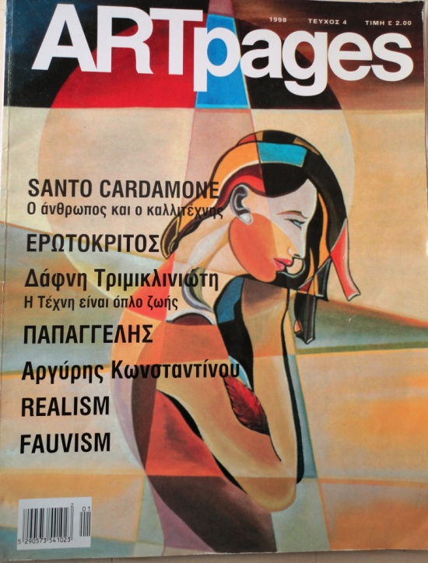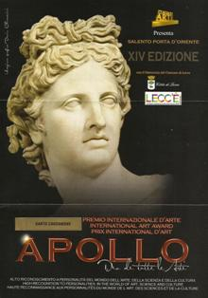

INFORMATION OF THE ART MARKET

Artistic premiums
Foreing: 73
Europe: 73
Italy: 9

Tested journalistic
Foreing: 9 / Articles in newspapers: 154 - Covers: 1
- Television documentaries: 33

Italy: 4 / Articles in news: 28
-Television documentaries: 7

Appearances in the Art Galleries
Foreing: 299
Europe: 46
Italy: 217

Presence and Sales in Auctions
Foreing: 7 (sales auctioned 28)
Maximum price achieved :
- 2005 canvas cm.60X90 £. 60.000
- 2013 Sculpture (2013) €. 120.000
Europa: /

Appearances in Museums and Private Collections

Foreing: 183 - Museum: 19
Europe: 91 //

FINAL JUDGMENT OF CRITICISM - CATALOG OF MODERN ART GIORGIO MONDADORI 47

Critique: AI (high interest) and SC (critical reporting) - Market: extension INT (international)
Range economic Painting: M (average € 9.000,00 to € 28.500,00 euro)
Source of prices: VP (made at public auction)
Range economic Sculpture: A (higher than € 28.000,00 euro - € 150.000,00 euro)
Frequency Market: M (foreign media) and L (limits on the Italian market).

Photos of artistic works in the highly successful marble.

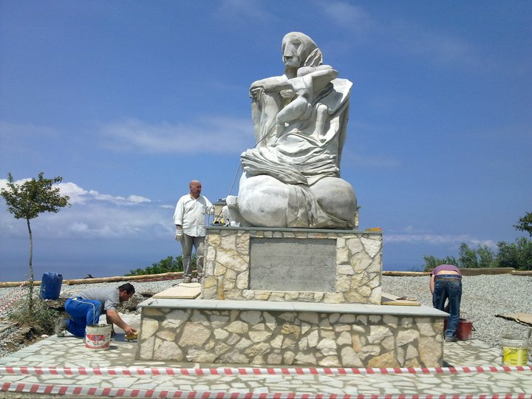
Sculpture Granite h. 9 meters. Sculpted personally by Cardamone.
It is the highest of Italy contemporary granite sculpture art.

